Installed Node.js
after installation with default settings -
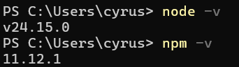
Checked for the versions of Node and npm (Node Package Manager).
The command below helped me to create a project using Next.js
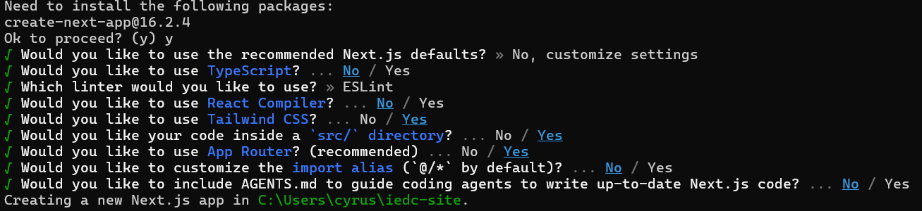
Installing
1. dependencies:
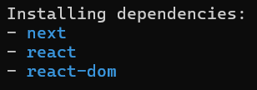
2. devdependencies:
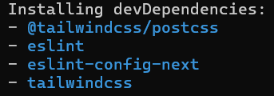
This helped me run the website that was created on the localhost server:3000.
